Министерство образования и молодежной политики Свердловской области

ГАПОУ СО «Екатеринбургский колледж транспортного строительства»

Отчет по ТРПО. Лабораторная работа №11  
**«Пользовательские элементы в WPF-приложениях»**.

Выполнил: Гордейчик С.А.

Группа: ПР-31

Преподаватель: Бушуева Е.В.

2024

Разметка:

<Window x:Class="Images.MainWindow"

xmlns="http://schemas.microsoft.com/winfx/2006/xaml/presentation"

xmlns:x="http://schemas.microsoft.com/winfx/2006/xaml"

xmlns:d="http://schemas.microsoft.com/expression/blend/2008"

xmlns:mc="http://schemas.openxmlformats.org/markup-compatibility/2006"

xmlns:local="clr-namespace:Images"

WindowStartupLocation="CenterScreen"

mc:Ignorable="d"

Title="Images" Height="800" Width="1200">

<Window.Resources>

<Style TargetType="local:ElementUserControl">

<Style.Triggers>

<Trigger Property="IsMouseOver" Value="True">

<Trigger.Setters>

<Setter Property="Panel.ZIndex" Value="99" />

</Trigger.Setters>

</Trigger>

</Style.Triggers>

</Style>

</Window.Resources>

<ScrollViewer>

<WrapPanel>

<local:ElementUserControl x:Name="Element1" />

<local:ElementUserControl x:Name="Element2" />

<local:ElementUserControl x:Name="Element3" />

<local:ElementUserControl x:Name="Element4" />

<local:ElementUserControl x:Name="Element5" />

<local:ElementUserControl x:Name="Element6" />

<local:ElementUserControl x:Name="Element7" />

<local:ElementUserControl x:Name="Element8" />

<local:ElementUserControl x:Name="Element9" />

</WrapPanel>

</ScrollViewer>

</Window>

<UserControl x:Class="Images.ElementUserControl"

xmlns="http://schemas.microsoft.com/winfx/2006/xaml/presentation"

xmlns:x="http://schemas.microsoft.com/winfx/2006/xaml"

xmlns:mc="http://schemas.openxmlformats.org/markup-compatibility/2006"

xmlns:d="http://schemas.microsoft.com/expression/blend/2008"

xmlns:local="clr-namespace:Images"

mc:Ignorable="d"

d:DesignHeight="450" d:DesignWidth="800">

<StackPanel Width="170" Margin="20" Background="White">

<StackPanel.Effect>

<BlurEffect x:Name="blur_1"></BlurEffect>

</StackPanel.Effect>

<StackPanel.Triggers>

<EventTrigger RoutedEvent="MouseLeave">

<BeginStoryboard>

<Storyboard>

<DoubleAnimation Storyboard.TargetName="blur_1" Storyboard.TargetProperty="Radius" To="5" Duration="0:0:1" />

<DoubleAnimation Storyboard.TargetName="scale_1" Storyboard.TargetProperty="ScaleX" To="1" Duration="0:0:1" />

<DoubleAnimation Storyboard.TargetName="scale_1" Storyboard.TargetProperty="ScaleY" To="1" Duration="0:0:1" />

</Storyboard>

</BeginStoryboard>

</EventTrigger>

</StackPanel.Triggers>

<TextBox x:Name="textbox"/>

<Image Width="170" Height="190" x:Name="image">

<Image.Triggers>

<EventTrigger RoutedEvent="MouseEnter">

<BeginStoryboard>

<Storyboard>

<DoubleAnimation Storyboard.TargetName="blur_1" Storyboard.TargetProperty="Radius" To="0" Duration="0:0:1" />

<DoubleAnimation Storyboard.TargetName="scale_1" Storyboard.TargetProperty="ScaleX" To="1.75" Duration="0:0:1" />

<DoubleAnimation Storyboard.TargetName="scale_1" Storyboard.TargetProperty="ScaleY" To="1.75" Duration="0:0:1" />

</Storyboard>

</BeginStoryboard>

</EventTrigger>

</Image.Triggers>

<Image.RenderTransform>

<RotateTransform x:Name="rotate" CenterX="85" CenterY="55"/>

</Image.RenderTransform>

</Image>

<StackPanel Orientation="Horizontal" Margin="0,0,0,10">

<Button Background="White" Width="30" Height="30" Margin="35 0">

<Image Source="ImagesSrc/left.png">

<Image.Triggers>

<EventTrigger RoutedEvent="MouseLeftButtonDown" >

<BeginStoryboard>

<Storyboard>

<DoubleAnimation Storyboard.TargetName="rotate" Storyboard.TargetProperty="Angle" By="-90" Duration="0:0:0.1"/>

</Storyboard>

</BeginStoryboard>

</EventTrigger>

</Image.Triggers>

</Image>

</Button>

<Button Background="White" Width="30" Height="30">

<Image Source="ImagesSrc/right.png">

<Image.Triggers>

<EventTrigger RoutedEvent="MouseLeftButtonDown" >

<BeginStoryboard>

<Storyboard>

<DoubleAnimation Storyboard.TargetName="rotate" Storyboard.TargetProperty="Angle" By="90" Duration="0:0:0.1"/>

</Storyboard>

</BeginStoryboard>

</EventTrigger>

</Image.Triggers>

</Image>

</Button>

</StackPanel>

<StackPanel.RenderTransform>

<TransformGroup>

<ScaleTransform x:Name="scale_1" ScaleX="1" ScaleY="1" />

</TransformGroup>

</StackPanel.RenderTransform>

</StackPanel>

</UserControl>

Код:

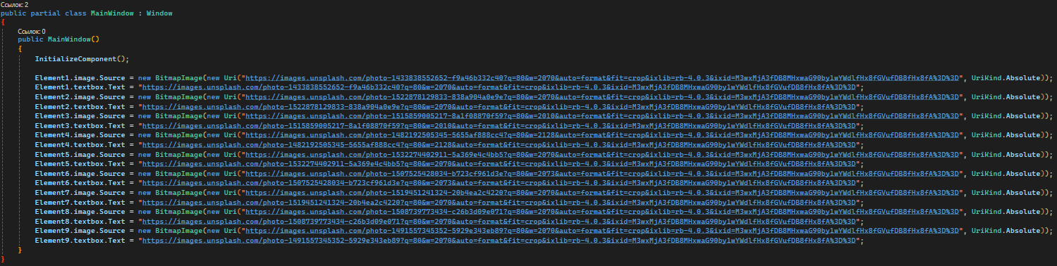

Снимок экрана:

